主题：用于挑战新鲜事物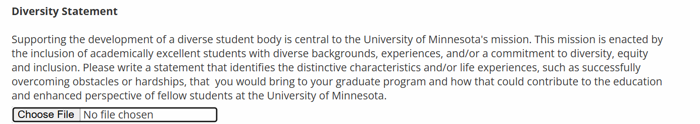

As a student in engineering, I have always believed that rather than focusing on one specific topic, a more diverse knowledge background is crucial to developing a unique research style and discovering innovative solutions. My commitment to interdisciplinary study, as demonstrated by my past experiences, aligns well with this philosophy.

My high school gave me a glance at how mathematics and physics theories connect each other, but I did not fully get the idea of how these connections would impact my career and research path until I became a physics student in my college, where I learned more about machine learning and received inspirations from how the interdisciplinary major study helped others to gain more success in their area.

Sourcing from this experience, even though I switched my major to computer engineering afterward, I never gave up studying mathematics and physics. I took additional high-level math and physics courses. While taking courses in ML, I still participated in math modeling contests with my friends and even received an honorable mention as a sophomore student. From my perspective, machine learning is an engineering tool developed based on probability theory that finds patterns by data, and math modeling is another tool that finds patterns by real-world logic. To me, it seemed that there was a strong possibility that these tools could complement each other in the future, which turned out to be true with the development of Physics-Informed Machine Learning in recent years.

I keep studying machine learning by myself as well as seeking guidance from one of my undergraduate research mentors, even though my research direction has turned to focus more on hardware. I published a paper discussing different machine learning models' impacts on disease prognosis. After the one-and-a-half year master's study, I began to realize that my diverse direction of study has provided me the ability to understand the most advanced technologies in robotics, and I believe that this is the research direction I would like to focus on. I had a chance to talk with Dr. Stephan Grossberg through emails and found that researchers have been working on Swarm Intelligence, which is a topic I developed an interest in when I first applied to computer engineering. I was grateful for how my experience provided me the ability to understand what these top researchers talked about and gave me a glance at the future direction of my research.

As a student who is still seeking advanced research, I am excited about the rapidly changing technology world as it presents challenges and opportunities. Thus, constant exploration in diverse areas is essential for a more creative and energetic research atmosphere. I believe that my multidisciplinary study would bring more creativity to the University of Minnesota, and I also hope that my experience could essentially inspire more people to come up with ideas in their research.